**The Alexandrine Parrot**

Alexandrines are originally from Asia. One of the first parrots to arrive in Europe was the Alexandrine named after Alexander The Great, who opened the trade routes and by which these regal birds were imported to the West in the middle ages.

The first records of these beautiful creatures in captivity goes back 400 years before Christ.In the Roman hey-day, to own an Alexandrine was a status symbol. These birds in Roman times had their own servant to look after them-not all that different from today really. The original Pirates Parrot.

It is because of this long history of domesticity, and the birds natural gentle nature that they are so suited to becoming a family member. For a bird that has been in captivity for so long, it is amazing so little information can be found, on the lovely Alexandrine.

As they have been domesticated for so long, these birds have no idea how to survive should they accidentally get away.

The wild life in this country soon kill them.

**So if you love your bird you will cut his/her wings**. (refer to Page 4)

Sadly because of reckless trapping and illegal export in their own native lands, the wild Alexandrines are fast disappearing. Doctor Harry claims these birds have a big brain. Once you have seen the show, you will no doubt agree with him.

**You have just acquired one of our Parrots in Paradise Babies**

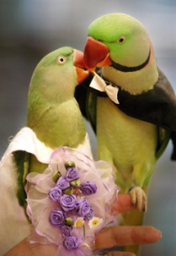{This means you have one of our beautiful and intelligent

Performers offspring}

**Your Baby Alexandrine:**

**His needs and how to handle him.**

When you get your baby the chances are that he/she is somewhere between 12 and 20 weeks old, It is important to remember that like all babies

he/she will need easy access to food and water at all times.

All our parrots are brought up to eat fruit and Alexandrines are

particularly large fruit eaters.

( if it is fruit you yourself wouldn’t eat, e.g. over ripe, then don’t give it to your baby )

Also I rear my babies to eat seed, pellets, nuts of all kinds, a varied diet is a healthy one.

(For full diet refer to Page 3)

Then there is berries like lillipilli. They really like to chew gravillia flowers.

If you see wild birds eating berries, you can be sure they are safe for your baby.

Lots of branches like bottle brush with the seed and brushes still on,

Alexandrines ( like all parrots ) have a beak that grows continuously like your nails,

so he/she **needs** to chew, and chew and chew! Lots of untreated wood and Pine cones.

If you want allow your baby to eat unhealthy foods i.e. coffee sweets and the like ***then make sure*** you give a fist sized lump of clay each week, this will do two things for you bird, first it puts a protective lining on the gut so the bird can cope with the not so healthy food, also clay is FULL of all kinds of minerals. Like kiddies Alexes**LOVE junk food**. Alexes also learn by example, and if they see you eating then it must be good.

It is best to show we know what are “good foods” and try not to eat too much junk food

around your new friend

**When you first take your baby home,** it is good to remember he will be a little lost,

he comes from a large family and is likely to miss them until he/she understands you are now the new family. So lots of company is good.

Your baby should have constant access to food and clean water.

It is also a good idea to keep an eye on babies weight, as it is at this time that baby can’t afford to loose any weight.

If you have children in your family they need to know that they have to move slowly they will get much more from the bird if it is allowed to have its personal *space*

Also like all babies your Alex will need to be in bed when it gets dark (with something nice, like a bickie or a piece of sugar cane to go to bed with ) as he gets older, then if you want, you can have him up later.

It has been my experience these birds love playing with kiddies if they are prepared to share their toys,

PLEASE make it OLD toys that can be broken, because Alexes**HAVE** to chew, plastic and soft toys are fine, **BUT BE CAREFUL** these birds do not know that swallowing metal can and often does kill them. ***Heavy metal poisoning*** is something **ONLY** an **avian** vet can cure, and only if get to as quickly as possible.

**The early signs are vomiting, dull, lots of drinking and no interest in food**.

Two Avian vets in **Brisbane**, **Dr Debby Monks**  Macgregor 34206773

And Dr **Adrian Gallagher** at Chermside Adrian is brilliant.

**I go to DorryHofman**on the Sunshine Coast **0423417495**

**Peter Wilson** for the Gold Coast

Annual avian vet checks are a good way to keep an eye on if you are treating your pal right.

**Your bird is a master in body language,**

**so watch and learn, there is much he/she can teach you.**

Once your bird gains confidence, it will see it’s cage in much the same way a teenager views their bedroom, ( you have to knock, and even then permition may not be granted.) this is the only little piece of the world the bird can call its own so it can become possessive. There really isn’t any harm in letting the bird have this little *space* It is also a good retreat if it gets tired of lively kiddies.

When asked to leave the cage, and the bird is not keen, then the bird may nip,

don’t get upset about this just use a piece of dowel or a stick when getting baby from the cage.He will get over it, and so will your fingers.

If baby nips when away from cage then use the *over balancing* trick, don't pull away but push back and overbalance baby, **not to hurt**, baby will very quickly give up the idea of nipping. One thing birds are completely unable to understand and that is being smacked or hit for doing wrong. A quick firm *NO!* it will quickly understand.

Because your baby is intelligent and bright, you will get hours of fun from him/her,

and like children you only get back what you put in.

There is another thing that needs to be carefully considered, if your bird is left for long periods on it’s own. They become very stressed if alone too much, it is best to get a friend,

of the same species

If you EVER need help or advice at ANY time do not hesitate to

Call **5438 7719**

Don’t forget to check out our website

www.parrotsinparadise.net

that is constantly being updated.

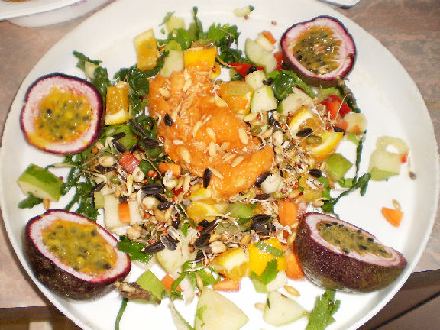

**The Diet I feed my birds.**

**Apple,** - Sometimes **Pear**  
**Orange or Mandarin**  
**carrot** --grated  
**Capsicum**  
**corn**  
**peas or beans**  
**celery**  
**silver beat**  
**soak seed or sprouted seeds**

These are weekly standards I make up containers of all of the above once a week  
adding one from the list below and serve them the fruit first thing in the morning.

For babies -if they eat most-then another small bowl after lunch.  
  
I try to introduce something new or different each week and these are some of them.

This way they don’t turn up their noses to anything they haven’t seenfore.  
  
**pawpaw**or **grapes**  
**pomegranate** (Eccies LOVE this)  
**melons,kiwi fruit, tomatoes**

**Guava, custard apples**

**peas and corn** - frozen  
**anything else** I can add to make a change  
  
I don't give up if they show no interest in one or another as I know a couple of days later

they will eat them.  
  
**biscuits** the ones that have that awful pink icing and hundreds and thousands (fairy sprinkles)  
**Parrot pellets** good quality nd**nuts** and **dried fruit**  
All my birds go silly over **pop corn**especially the "pretty" ones  
Things like crunchy type **nut clusters--curios---any cerea**l,  
What I do is make up a container with all of the above and when it is time for the evening meal

The birds are given the “dry” mix  
Then there is **mixed seed** and ( favorite is sunflower ) for youngsters

and particularly Alexes it is OK with them having GREY STRIPED Sunflower

(**not good for native birds**)

Just for special treats and to give a bit of protein I let them have a few  
**dog biscuits** (beef and vege) The dog biscuits I put in the cereal mix  
  
and a tiny piece of **cheese** now and then.

All parrots like cooked rice, cooked sweet potatoes, (very good)

actually whatever is on your plate.  
  
I know it seems a lot but it won't take you long to work out how much will last you a week.  
My containers of fresh fruit and vege are LARGE and many of them.

I feel I am forever filling the cereal mix. but**All my birds** eat all that list,

even our wee bush budgies.

**THE BIG NO! NO!DO NOT GIVE YOUR BIRD AVOCADO!**

**The Pros and cons of wing clipping**  
  
This is a tough question, it all depends how you want your bird to fit into your family life.  
There are two schools of thought here.  
  
Of course birds have wings and are designed to fly, but you have to remember that you are asking your bird to be your companion, and in return you will supply all of his wants and needs.  
  
In the wild your bird mainly uses flight to get to and from food and water, find a mate, then nesting and all that entails, then there is the all important escape from danger.  
So if you covering all, or most of the above, then flight is not such an important thing.  
  
You can have you and your bird trained to "recall" using positive reinforcement.  
First you have to find someone prepared to train you to train your bird.  
While this is the most natural way, it has its dangerous side.  
You are allowing your bird to interact with the very real dangers that are out there in the wild,

and if your bird gets a very real fright, and is perhaps being chased by a territorial or predatory bird "recall " can get somewhat unglued.  
  
In the average home where a bird is set up to live there are very real dangers for a flighted bird. Hot cooking items, ceiling fans, electrical appliances, electrical cords, sources of heavy metal ( zinc, lead, pewter, copper, jeweler) or other pets, (dogs cats and other birds).  
  
If the bird has its wings clipped then it may have a much better quality of life, and is much more likely to be taken out of its cage and enjoy more company. Which it what all companion birds need, perhaps a play gym with lots of toys and food.  
**It is VERY important to make sure the wing clip is done correctly**.  
Too little, (or incorrectly cut) can result in in a gust of wind or that powerful shot of adrenaline can take a bird with a clipped wing a long way! So too can the **forgetting** to clip the new flights, (all too many birds are lost this way).

HOWEVER it is really cruel to "over clip" what

often happens is bird crashing too heavily and

can result in muscle damage,

skin splitting, abscesses even fractures.  
Too closer cut can damage the birds ability to

grow more new feathers, and when new flights

try to come through, abscesses are likely.  
  
I personally have all my birds clipped,

so they can enjoy so much more freedom.

They know I will provide all their needs and

I do have a happy flock that, in most cases,

are friendly and interactive with each other

and with humans.

